LAB-3 ASSIGNMENT

1. Extend the Mobile Web Client Application you implemented in Lab 2 **with HTML5 Local Database**.

Below is the screenshot of the Application I have created in lab-2

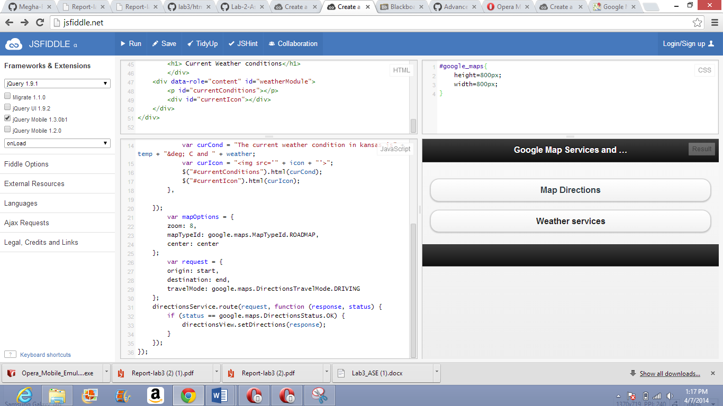

I have extended the application using HTML5 Local Database by adding the following login features. The screenshots generated in opera mobile emulator are shown below.

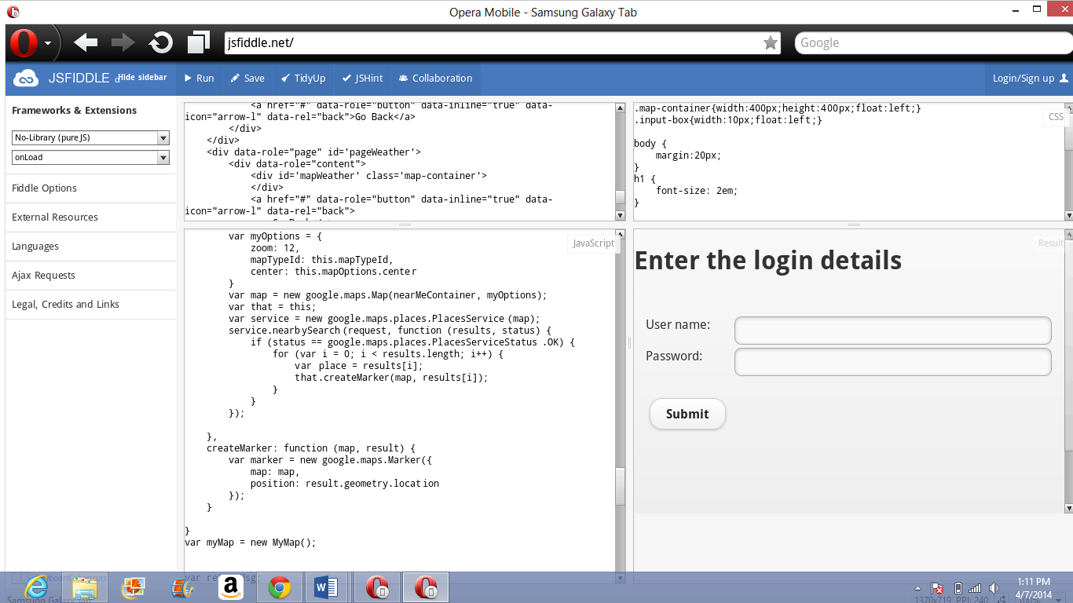

The user can enter the login details

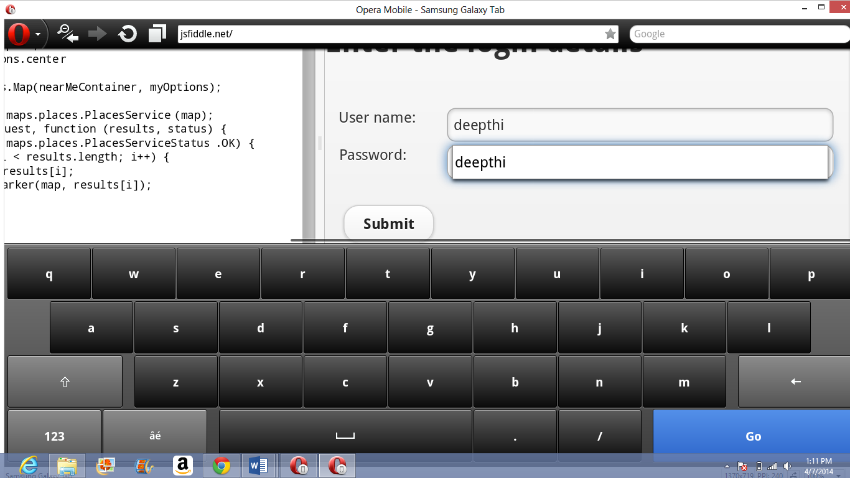

The user will be redirected to the home page as shown below and if the user is new to the site Welcome new user message will be displayed on the top.

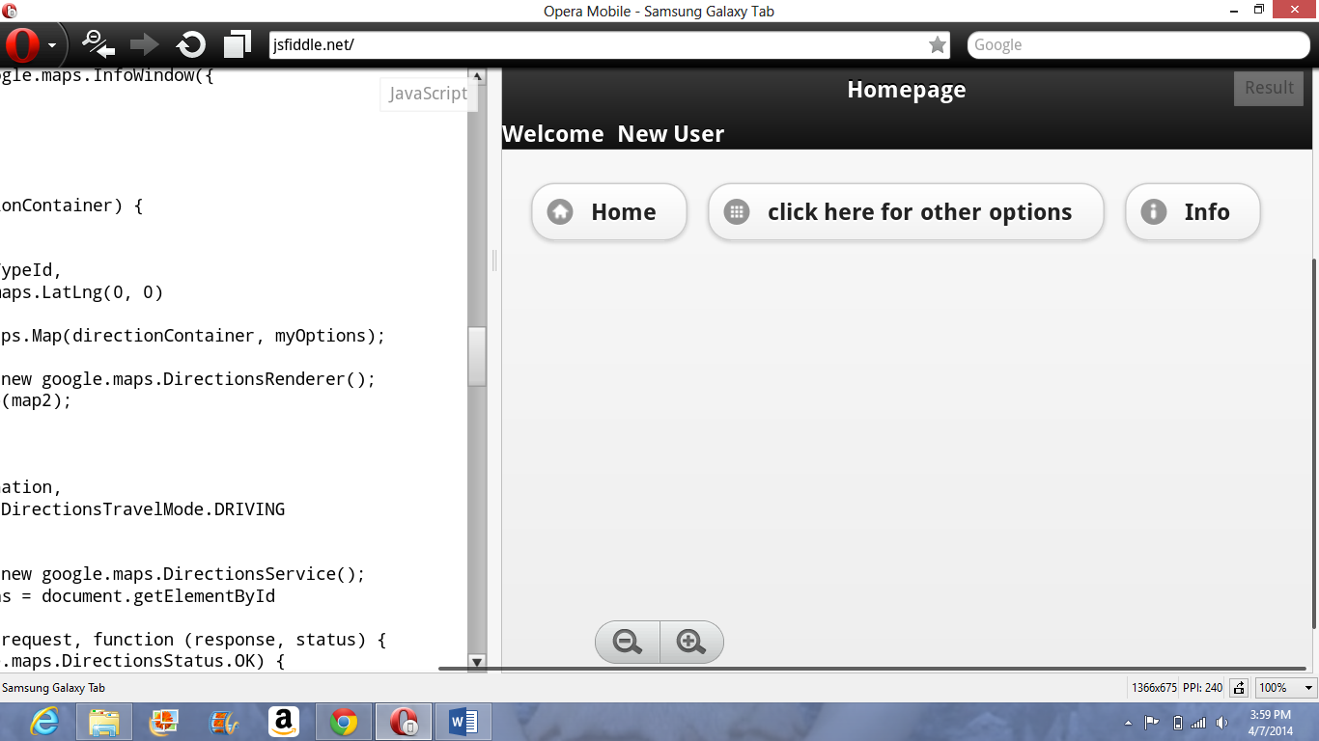

When you click the button “click here for other options” you will be redirected to the following page with Get Directions and Weather Information.

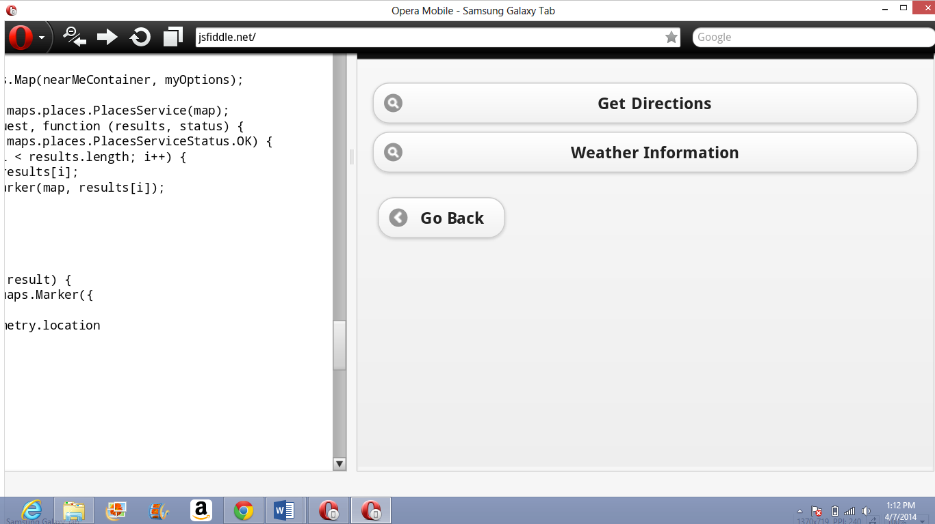

When you click Get Directions below screen will be displayed.

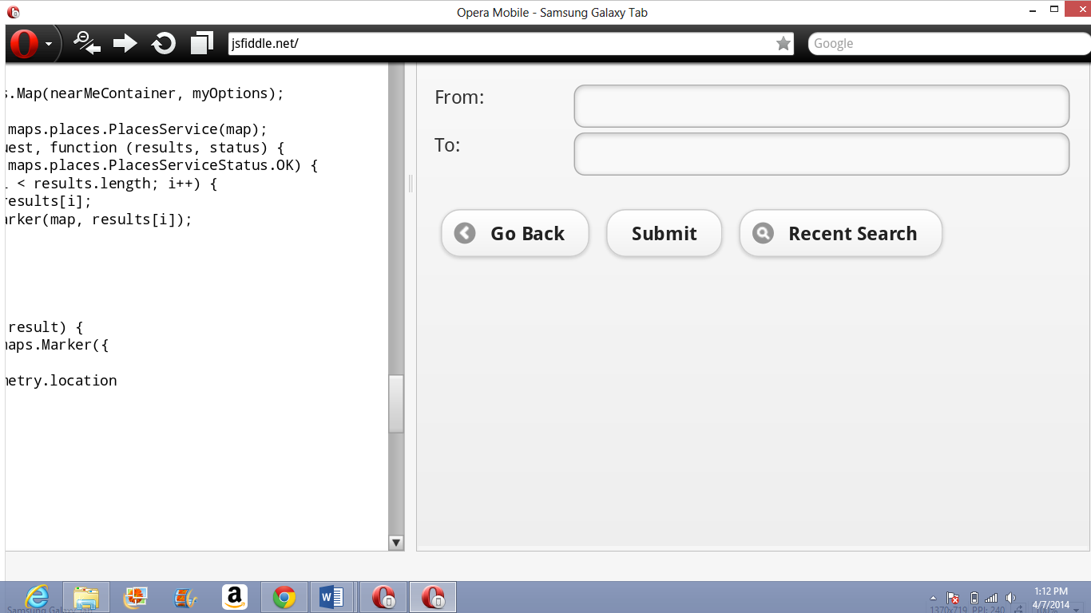

You can enter the credentials you want to.

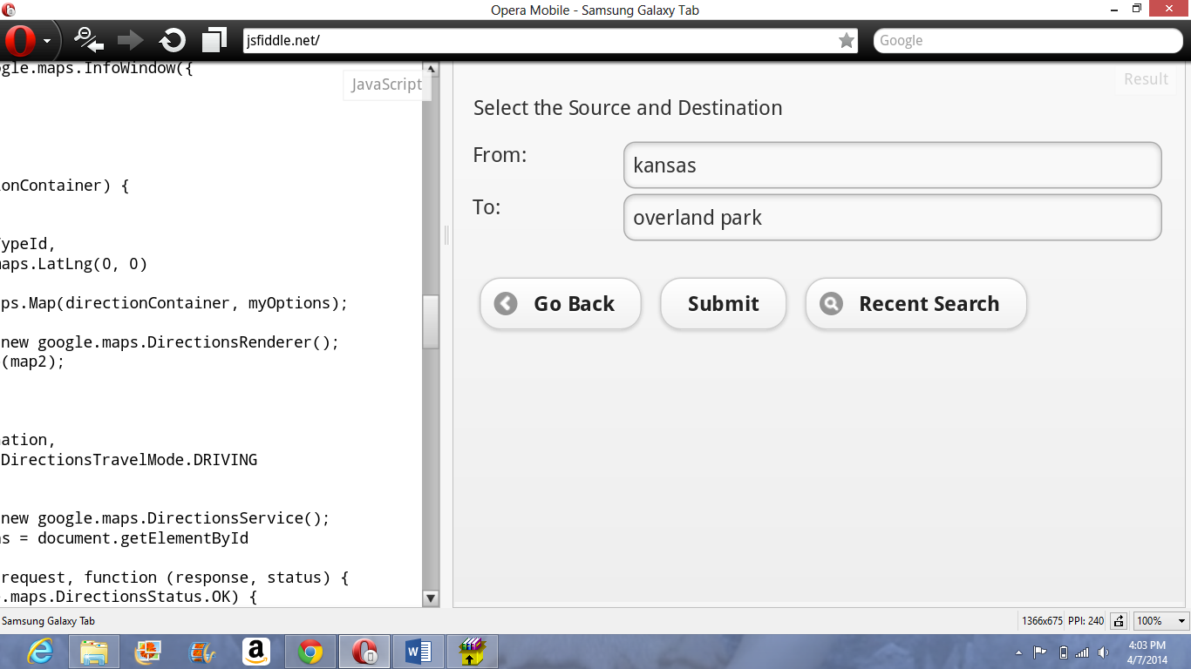

When you enter the places following map will be displayed.

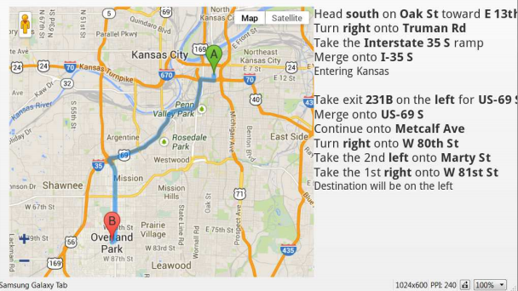

When you click the GO BACK option and click for the weather information below screen will be displayed.

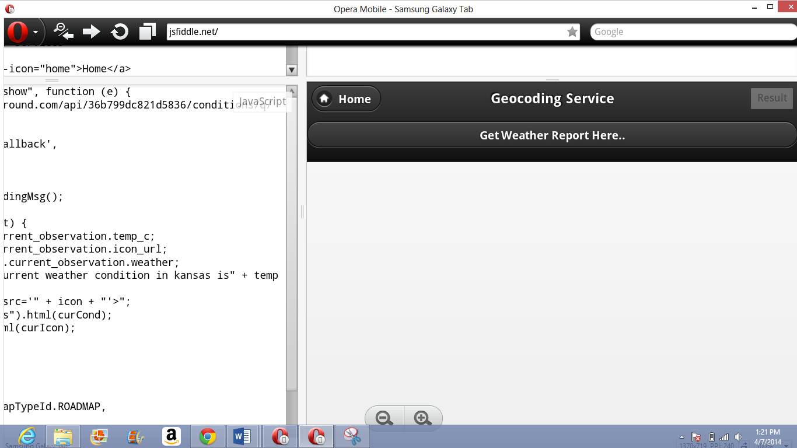

When you click the option get weather report here option the weather report will be displayed.

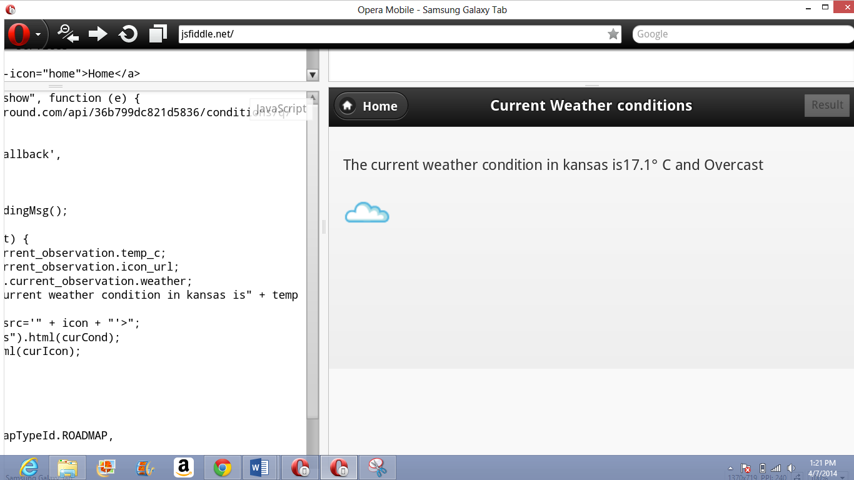

2. Mashup Application

I have created the following mashup application with including Google maps which shows the directions between two places.. Here I have given from Kansas to St. Louis.

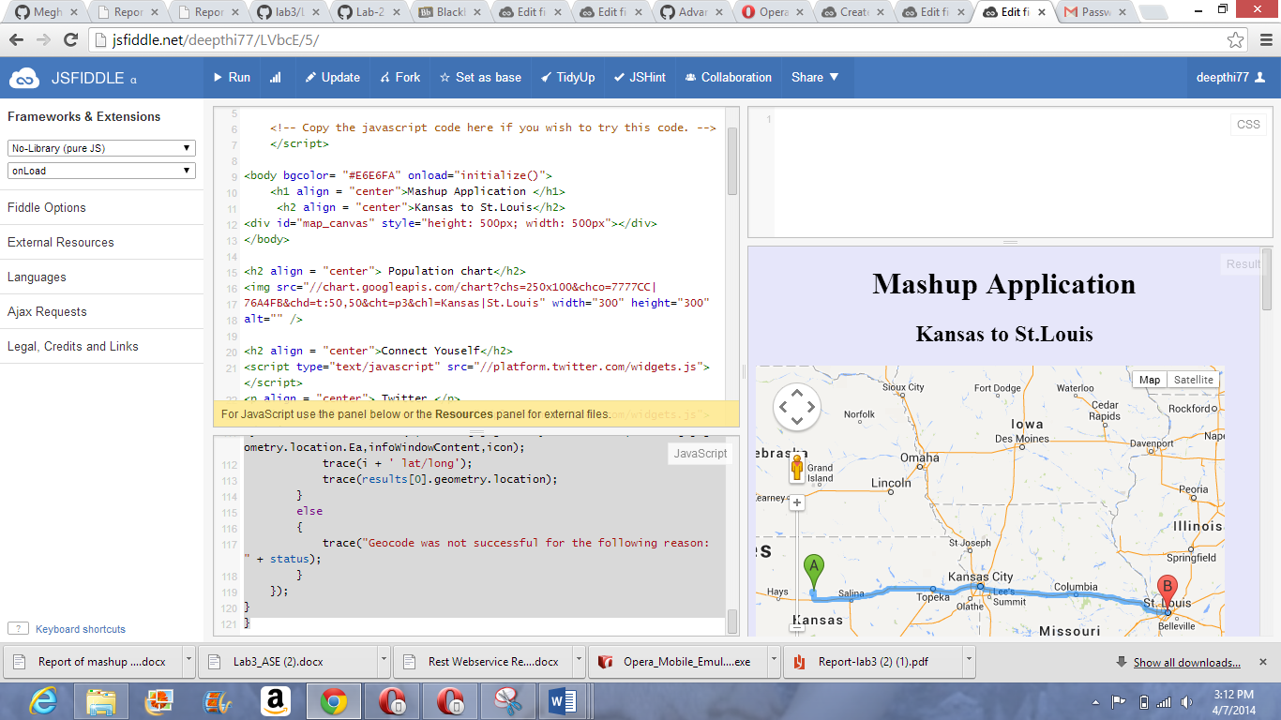

Flow chart to compare the population between these two states

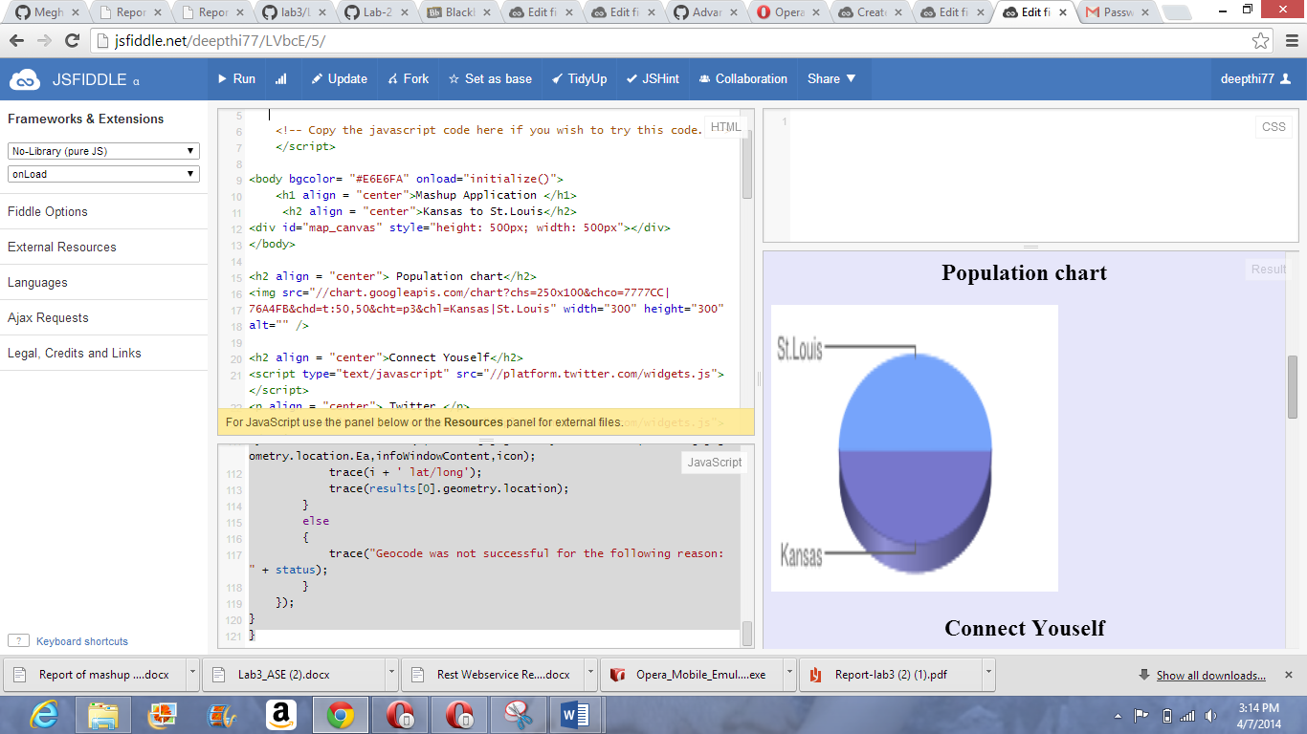

And also the social networking sites facebook and twitter to like, connect and share.

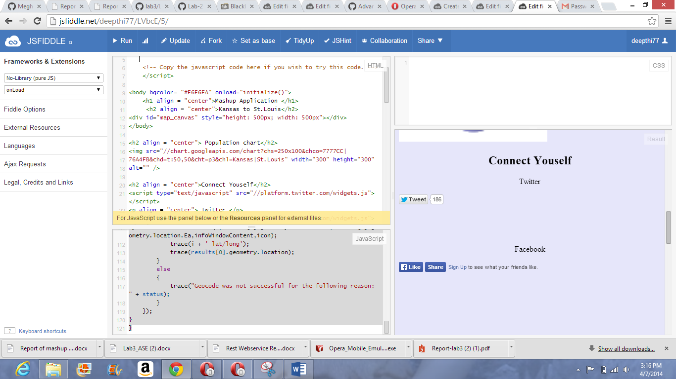

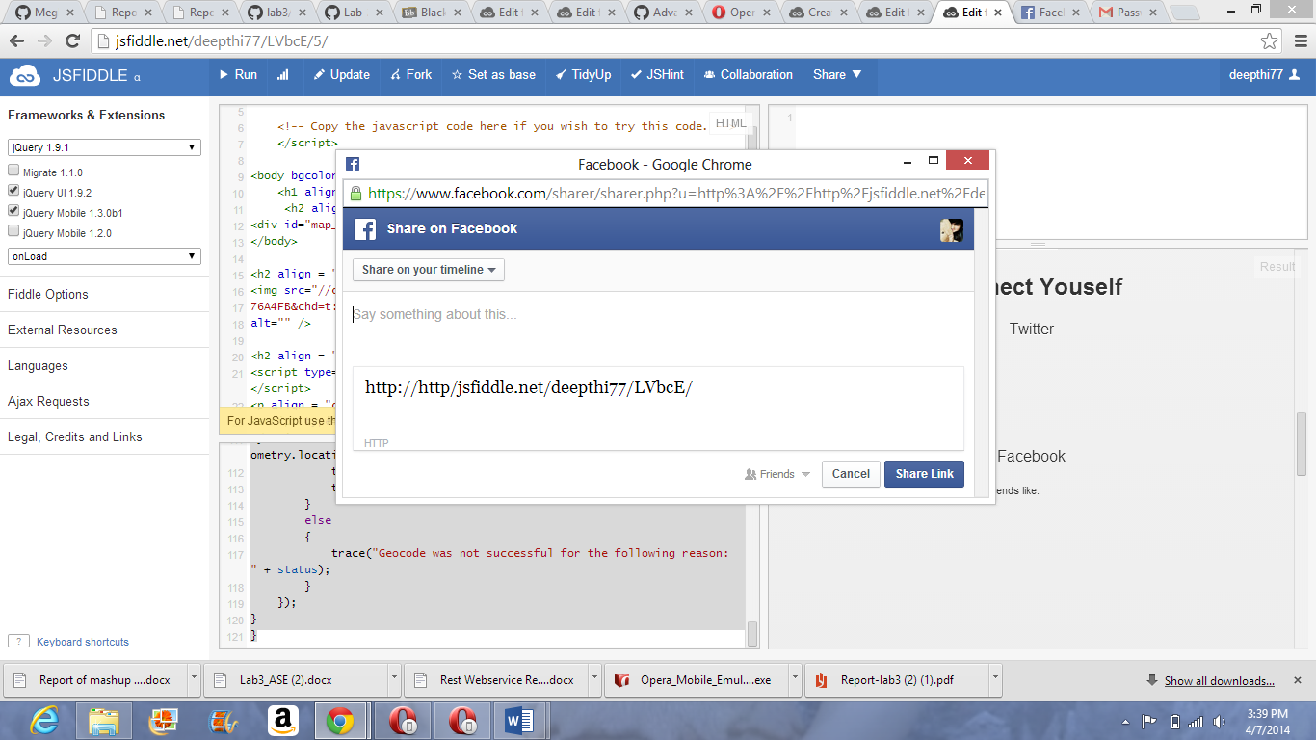

3. Implement your own REST Web Services (Refer to Tutorial 5) and use them from your client application.

I have created the following REST Web Services by using Visual Studio

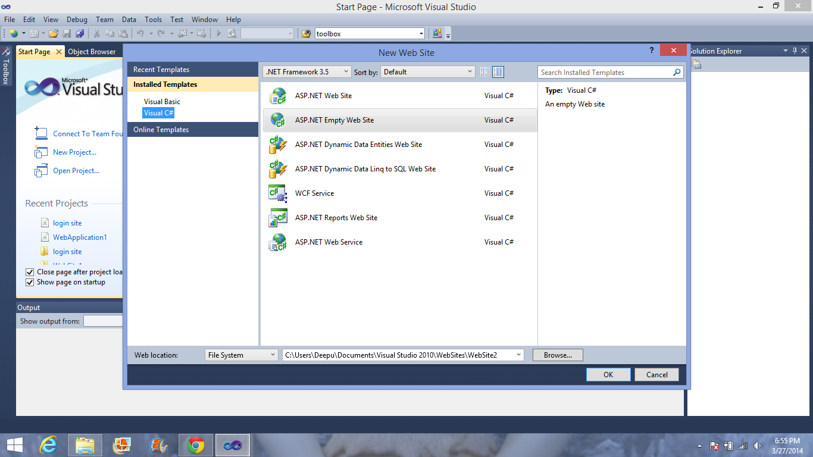

2. These is how I created the cells required for the login page

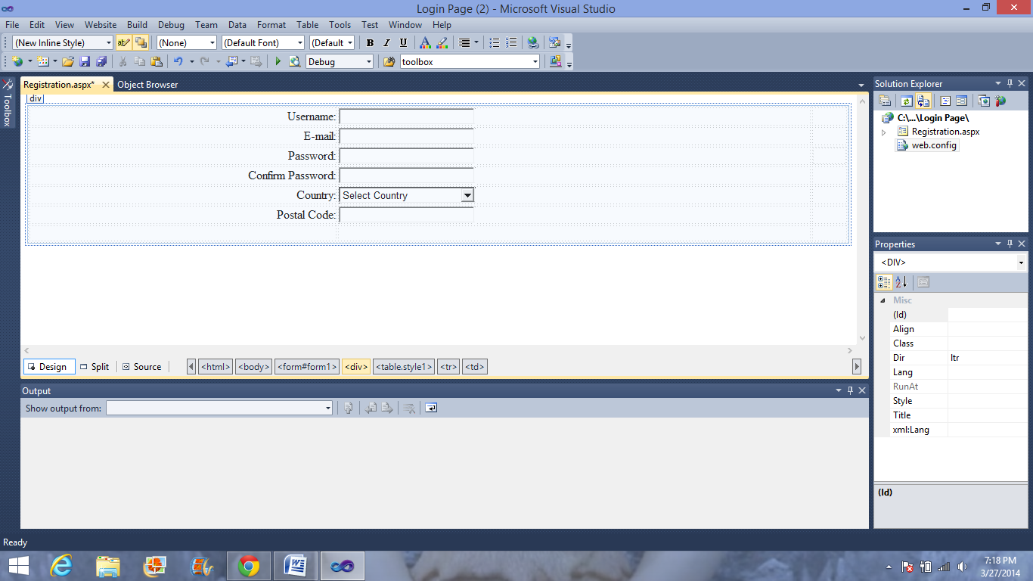

3. In desktop it appears as follows.

